**THEME 5: Around Town - Grade 6**

**Week 14** **- P: 38, 39, 40**

**Date: 06/12 – 11/12**

**LESSON 1**

**Exercises**

**New words**

**a. Use the words in the box to label the pictures.**

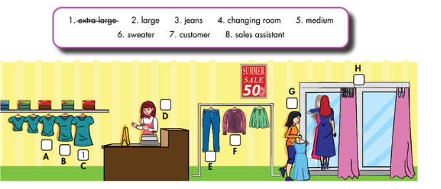

**b. Fill in the blanks using the words in Task a.**

1. This T-shirt is very big. It’s an extra large size.

2. Do you have this dress in a …………..………..size? This medium one is too small.

3. A: Do you have these ………………….in dark blue? Can I try them on?

4. B: Sure. The ……………………….is over there.

5. A ………………………….works in a store.

6. The ………………….wants a medium blue dress.

7.A: This pink …………………….is so nice. How much is it?

B. It’s ten dollars.

8. That blue jacket was too big. This one is too small.

Do you have it in a ………………………..size?

Grammar

a. Circle the correct answers.

1. A: Do you have this / these shoes in black?

B: Yes, do you want to try it / them on?

A: Yes, please. How much is / are they?

B: It’s / They’re thirty-five dollars.

2. A: Do you have this / these dress in red?

B: Yes, do you want to try it / them on?

A: Yes, please. How much is / are it?

B: It’s / They’re forty-three dollars.

b. Circle the mistakes. Use this/these, is/are to correct the sentences.

1. These T-shirt is very big. Do you have a smaller one? This

2. A: Do you have this jeans in dark blue? Can I try …….

Them on?

B: Of course. The changing rooms is over there. ……..

3. A: This pink skirt are so nice. How much is it? ……..

B: It are ten dollars.

4. These blue jacket is too big. Do you have it in a medium size? ……..

5. A: How much are this jacket? ……….

B: It are twenty-five dollars. ……….

Writing

Complete the conversation with the given phrases or your own ideas.

